**ABORIGINAL BEREAN COMMUNITY CHURCH**

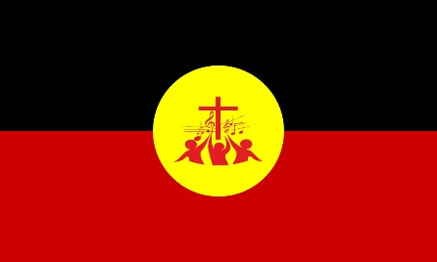

* The Church has some older and active members who are not able to contribute as they have in the past. Pray for them to feel honoured, for wisdom as to how to pass on the baton and for the raising up of new leaders.
* The Church has a role in the community far beyond its size and capacity to manage. Pray for those they have connected with in the community, that all may find their true hope through a relationship with Jesus. Pray for wisdom for the Church to know where to put their energies.
* There are always many and often complex health issues (spiritual, relational, physical) that are going on within people connected with the Church. Pray that all may meet God in deep ways and find true healing and fullness of life in their relationship with Him.
* God is bringing many young people to the Church and many are responding in faith. But with them come some real complexities. Pray for the leadership and church as a whole that they may care for and nurture these young people and grow leaders well.

**Pastor Don Hayward**

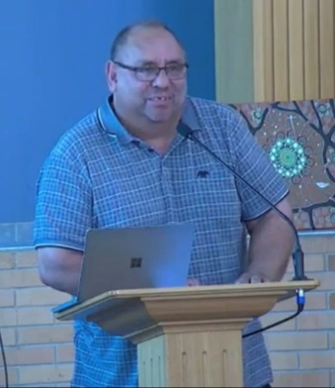

* Pastor Don has been struggling with ongoing health challenges. Pray for real and deep healing that he may continue to serve well.
* Pastor Don is often called upon to serve in many areas outside of the Church (i.e. funerals and national councils). Pray for energy and wisdom for what he needs to say “Yes” and "No” to.
* Pastor Don is keen to help develop the emerging leaders who are within the Church, pray that he may be able to do this well and effectively.

**Jack Harradine**

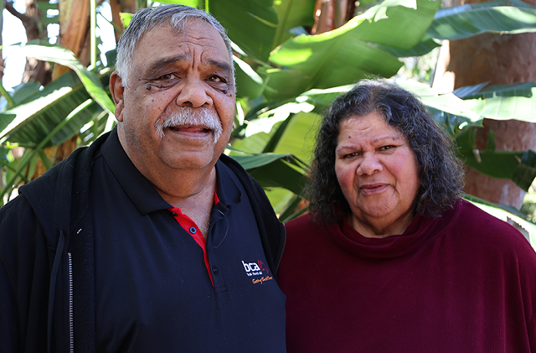

Jack and his wife Lill

* Jack continues to serve in remote communities to share the love of Jesus. Pray for health to be able to do so and wisdom to know where to invest his time and energies.
* Pray for his current work in Point McLeay and the bible studies there.
* Pray for those who receive the Word, that it may be planted well and develop good roots so that what God has begun may be sustained and grow.

**Lonnie**

* Lonnie is back from studying in Melbourne, having obtained a Diploma in Theology. He is looking at being more involved in the leadership and ministries of the Church. Pray for good support systems around him and for God's protection over Him.
* Lonnie is needing to find some paid employment. Pray that the right employment is found that enables him to pursue the ministry God is calling him to.